**NAME: ABDURRAHMAN QURESHI**

**ROLL NO: 210451**

**EXP7**

**Apply tags to color the links**

**Code:**

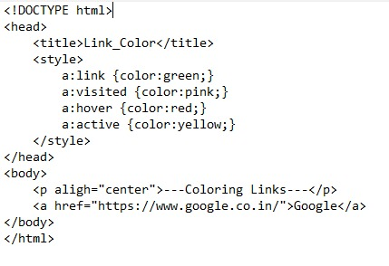

**Output:**

**Link color:**

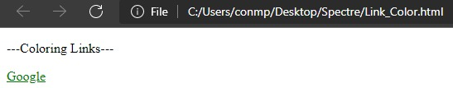

**Visited Link:**

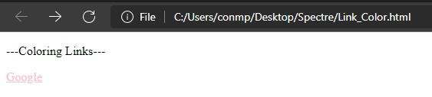

**Hovering on the Link:**

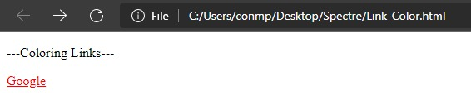

**Active Link:**

